# Overview

This project is aimed at developing your own recommendation system and comparing the results of the system built by you with a standard recommender system library. The data source to be used is: User- TVShow, an overview of the dataset is given later in the below sections. [MyMediaLite](http://www.mymedialite.net/) library is used for comparing the results. You can do the assignment using Java or Python.

# Problem Description

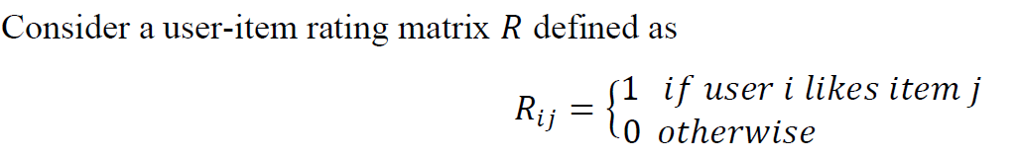

Let there be 'm' users and 'n' items, hence R is (m x n) matrix. Now let P be an (m x m) diagonal matrix whose ith diagonal element represents the number of items that are liked by the ith user. Let there be another diagonal matrix Q of order (n x n) whose jth diagonal element represents the number of users who have liked the item 'j'. Below is an illustrated example.

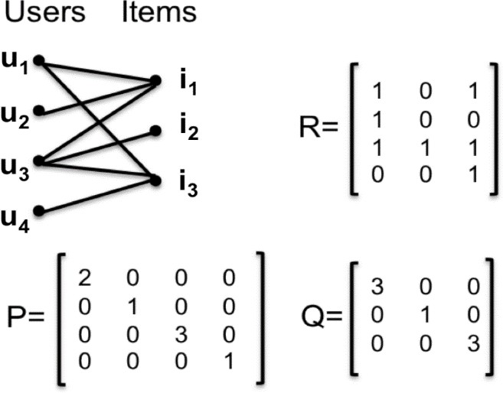

# Exercises

**Exercise 1** 



# Exercise 2

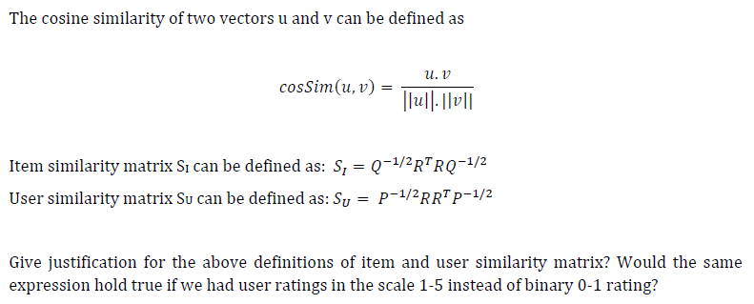

# Exercise 3

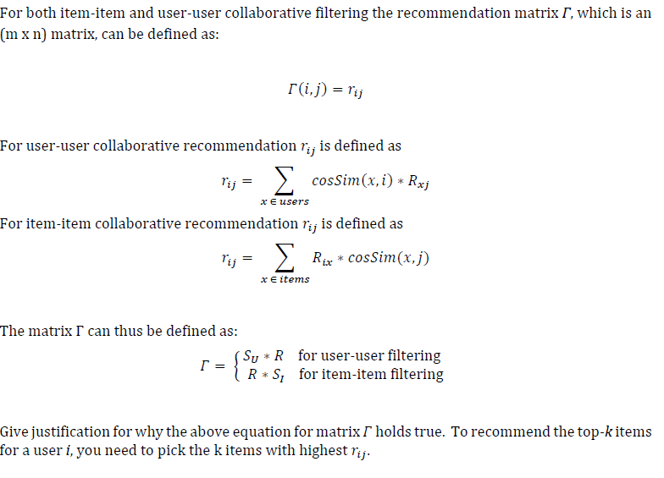

# Exercise 4

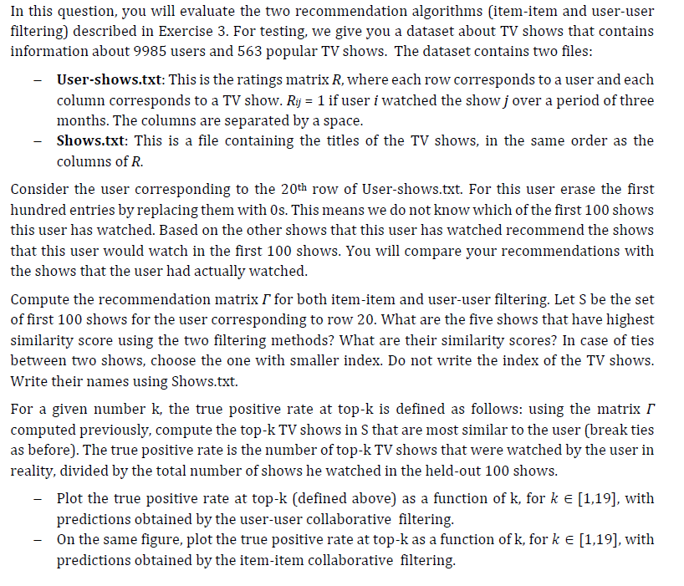

# Exercise 5 [20 points]

For the 20th user in the dataset list out the Show IDs of the top-10 recommended TV shows using the following methods (here you don’t need to erase the 100 entries as you did in exercise 4):

1. Item-item collaborative filtering (as discussed in the assignment)
2. User-user collaborative filtering (as discussed in the assignment)
3. ItemKNN (use [MyMediaLite’s Item Recommendation](http://www.mymedialite.net/documentation/item_prediction.html) program)
4. WRMF (use [MyMediaLite’s Item Recommendation](http://www.mymedialite.net/documentation/item_prediction.html) program)

Use the following format to list the result:

|  |  |  |  |
| --- | --- | --- | --- |
| **Item-item** | **User-user** | **ItemKNN** | **WRMF** |
| ShowID1 | ShowID1 | ShowID1 | ShowID1 |
| ShowID2 | ShowID2 | ShowID2 | ShowID2 |
| . | . | . | . |
| . | . | . | . |
| . | . | . | . |
| ShowID10 | ShowID10 | ShowID10 | ShowID10 |

Also provide the Show names for the above table as follows:

|  |  |
| --- | --- |
| **ShowID** | **ShowName** |
| ShowID1 | Show Name 1 |
| . | . |
| . | . |

Now compare the four ranked lists obtained using [Kendall Tau](https://en.wikipedia.org/wiki/Kendall_tau_distance) distance and report your findings in the form of a matrix given below. List down the rankings that are closest based on this measure:

|  |  |  |  |  |
| --- | --- | --- | --- | --- |
|  | **Item-item** | **User-user** | **ItemKNN** | **WRMF** |
| **Item-item** |  |  |  |  |
| **User-user** |  |  |  |  |
| **ItemKNN** |  |  |  |  |
| **WRMF** |  |  |  |  |